<<MIN PROJECT TITLE>>
A Mini Project report submitted to
NARAYANA ENGINEERING COLLEGE (AUTONOMOUS), NELLORE
(Affiliated to Jawaharlal Nehru Technological University, Anantapur, Ananthapuramu)
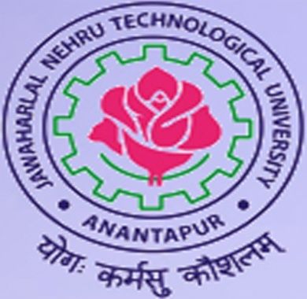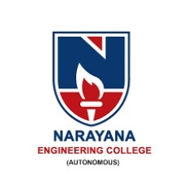
In partial fulfilment of the requirements for the award of Degree of
Bachelor of CSE – ARTIFICIAL INTELLIGENCE (CAI)

BY
<<NAME 1>> <<(Roll Number)>>

Under the guidance of
<< GUIDE NAME >>
<< DESIGNATION >>

DEPARTMENT OF CSE - ARTIFICIAL INTELLIGENCE (CAI)

August, 2026
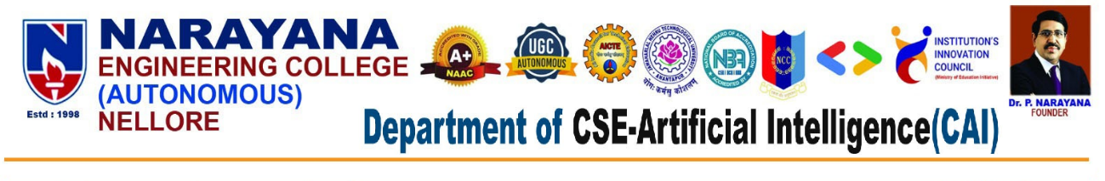



CERTIFICATE

This is to certify that the mini project report entitled “PROJECT TITLE” submitted by NAME 1 (Role Number) of the Department of CSE – Artificial Intelligence (CAI), Narayana Engineering College (Autonomous), Nellore, is a bona fide record of the work carried out by them under my guidance and supervision during the academic year 2026-2027

Signature of the Guide Signature of the HOD
GUIDE NAME Dr. C. Rama Mohan _{M.Tech., Ph.D.}
Designation Professor & HOD
Department of CSE-AI (CAI) Department of CSE-AI (CAI)
Narayana Engineering College Narayana Engineering College
Nellore- 524004 Nellore- 524004



VISION OF INSTITUTION
To be one of the nation’s premier Institutions for Technical and Management Education and a key contributor for Technological and Socio-economic Development of the Nation.

MISSION OF INSTITUTION
Requirements & actions are identified to achieve the vision
 | M1 | To produce technically competent Engineers and Managers by maintaining high academic standards, world class infrastructure and core instructions.
 | M2 | To enhance innovative skills and multidisciplinary approach of students through well experienced faculty and industry interactions.
 | M3 | To inculcate global perspective and attitude of students to face real world challenges by developing leadership qualities, lifelong learning abilities and ethical values.

VISION OF DEPARTMENT
To empower students to become AI professionals, driving industry innovation to meet the needs of Industry and society through cutting-edge technologies along with research and consultancy, lifelong learning, leadership qualities and ethics.

MISSION OF DEPARTMENT
Requirements & actions are identified to achieve the vision
M1 | To establish a solid foundation by quality technical education in Artificial Intelligence and effectively teaching Learning process to make self sufficient individuals.
M2 | To develop resilient professionals by inculcating problem solving skills to create applications for industry innovation.
M3 | To cultivate professional behavior with ethical values, leadership and lifelong learning that have a positive impact on society through value based education.
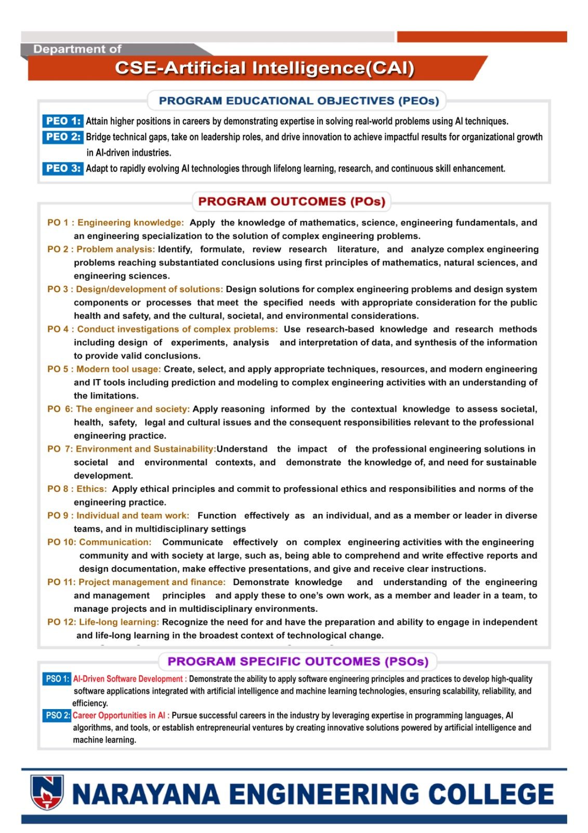

DECLARATION
We hereby declare that the project entitled <<PROJECT TITLE>> has been done by us under the guidance of <<GUIDE NAME>>, <<Designation>>, Department of CSE-AI (CAI). This Project work has been submitted to NARAYANA ENGINEERING COLLEGE, NELLORE as a part of partial fulfilment of the requirements for the award of degree of CSE – AI (CAI).
We also declare that this project report has not been submitted at any time to another institute or University for the award of any degree.

Project Associate’s
NAME 1 (Role Number)

Place: NELLORE
Date:

